Deploy Assigned Access

Deploying assigned access can be done using various methods this method we will be downloading the necessary bits from GitHub and Deploying via WMI Bridge as System using PSExec. We have put the logic together on get hub to provide a foundation to get started.

<https://github.com/Mauvlans/AssignedAccess/tree/master/AA%20via%20WMI%20Bridge>

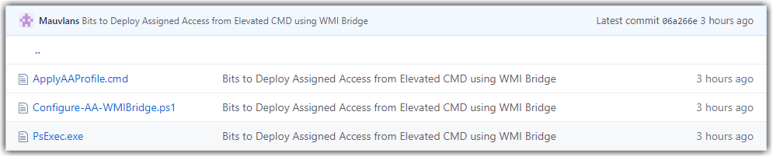

#### ApplyAAProfile.cmd:

The ApplyAAProfile.cmd script is to execute PSExec as an elevated process and execute the PowerShell script which will apply our Assigned Access. This is meant to be executed as admin, this is commonly done by right clicking and selecting “Run as Administrator”

NOTE: this script is hard coded to be ran from a specified directory be sure to take a few moments to update the

SET CurrentDir="%~dp0"

cd %CurrentDir%

psexec.exe -i -s powershell.exe -ExecutionPolicy Bypass -File "c:\Util\aa\Configure-AA-WMIBridge.ps1" 2> Log.txt

#### Configure-AA-WMIBridge.ps1:

The Configure-AA-WMIBridge.ps1 script will take your assigned access XML profile you can copy the entirety of the profile between the @” and “@. This will apply the profile defined to the MDM AssignedAccess.

$nameSpaceName="root\cimv2\mdm\dmmap"

$className="MDM_AssignedAccess"

$obj = Get-CimInstance -Namespace $namespaceName -ClassName $className

Add-Type -AssemblyName System.Web

$obj.Configuration = [System.Web.HttpUtility]::HtmlEncode(@"

<<< Assigned Access XML >>>

"@)

Set-CimInstance -CimInstance $obj

#### PsExec.exe:

This is the PsExec bits as part of System Internals. You can use this or an updated exe.

### Execution:

To execute,

* 1. Copy the 3 files to a working directory on the local machines.
  2. Update the ApplyAAProfile.cmd to reflect the current working directory.
  3. Update the Configure-AA-WMIBridge.ps1 with the desired assigned access profile.
  4. Prep the underlying host with any necessary application, User Accounts, configurations.
  5. Apply the AA profile by running ApplyAAProfile.cmd as admin.
  6. Check the log.txt output in the execution directory for any errors.
  7. Logout and login as the AA user and validate profiles successfully applied.